Algorithms in Machine Learning
Final Project
2024-26
Understanding Market Capitalization Through Financial Performance and ESG Factors

Team Members:-
Anamika Sharma RBA26
Palak Sahu RBA51
Sourav Manna RBA70

Contents
1. INTRODUCTION 5
1.1 Background of the Study 5
1.2 Objectives of the Study 5
1.3 Need and Relevance of the Study 6
1.4 Business and Societal Context 7
2. DATASET DESCRIPTION 8
2.1 Dataset Source and Overview 8
2.2 Structure of the Dataset 9
2.3 Description of Key Variables 9
2.3.1 Financial Variables 10
2.3.2 ESG and Sustainability Variables 10
2.3.3 Categorical Variables 11
3. EXPLORATORY DATA ANALYSIS (EDA) 11
3.1 Univariate Analysis 11
3.2 Bivariate Analysis 14
3.3 Trends Across Time (2015–2025) 19
3.4 Initial Insights from Exploratory Data Analysis 21
4. DATA PREPROCESSING AND FEATURE ENGINEERING 22
4.1 Handling Missing Values 22
4.2 Outlier Detection and Treatment 24
4.3 Transformation of Categorical Variables 25
4.4 Feature Scaling and Transformation 26
4.5 Train–Test Split Strategy 27
5. REGRESSION ANALYSIS: MARKET CAPITALIZATION PREDICTION 28
5.1 Regression Problem Formulation 28
5.2 Models Considered 29
5.3 Model Evaluation Metrics 30
5.4 Comparative Performance of Regression Models 31
5.5 Selection of the Best Regression Model 32
5.6 Interpretation of the Final Regression Model 34
5.7 Feature Importance and Business Meaning 35
6. Classification Methodology 36
6.1. Objective of Classification 36
6.2 Market Capitalization Classification Framework 36
6.3 Classification Models Employed 38
6.3.1 Multinomial Logistic Regression – Interpretation & Insights 38
6.3.2 K-Nearest Neighbors (KNN) – Interpretation & Insights 39
6.3.3 Support Vector Machine (SVM) – Kernel-wise Analysis 40
6.3.4 Decision Tree Classifier 43
Confusion Matrix Interpretation 44
6.4 Evaluation Metrics Used 45
6.5 Model Evaluation and Comparative Analysis (Before Tuning) 45
Key Findings from Model Evaluation 45
7. MODEL TUNING AND OPTIMIZATION 47
7.1 Need for Hyperparameter Tuning 47
7.2 Tuning Methodology 47
Best Hyperparameters Obtained: 47
7.3 Performance Comparison (Before vs After Tuning) 48
Key Observations: 48
Feature Importance Analysis 48
7.4 Selection of Best Classification Model 50
7.5 Justification for Final Model Choice (Decision Tree Classifier) 51
7.5.1 Confusion Matrix Interpretation (Tuned Decision Tree) 51
7.5.2 Why Decision Tree is the Best Model 52
8. BUSINESS INSIGHTS FROM FINAL MODELS 52
8.1 Key Drivers of Market Valuation 52
8.2 Role of Financial vs ESG Factors 53
8.3 Differences Across Market Cap Segments 54
8.4 Strategic Patterns Identified 55
9. BUSINESS APPLICATIONS AND RECOMMENDATIONS 55
9.1 Investment and Valuation Applications 55
9.2 Strategic and Operational Applications of the Predictive Models 56
10. CONCLUSION 57
10.1 Summary of Findings 57
10.2 Managerial Takeaways 58
11. REFERENCES 58

1. INTRODUCTION

1.1 Background of the Study
In recent years, firm valuation has evolved beyond a purely financial assessment to incorporate non-financial factors, particularly Environmental, Social, and Governance (ESG) considerations. Investors, regulators, and corporate stakeholders increasingly recognize that long-term firm value is influenced not only by revenue growth and profitability but also by sustainability practices, resource efficiency, and responsible governance. This shift has led to growing interest in understanding how traditional financial indicators and ESG metrics jointly shape market capitalization and firm classification.
At the same time, advances in data analytics and machine learning have enabled more sophisticated modeling of complex, non-linear relationships that are difficult to capture using conventional statistical techniques. Financial and ESG variables often interact in ways that are dynamic and context-dependent, varying across industries, regions, and stages of firm growth. Machine learning models provide a data-driven framework to analyze these interactions and generate predictive insights with higher accuracy and interpretability.
Against this backdrop, the present study examines a global dataset of companies spanning multiple industries and regions over the period 2015–2025. By combining financial performance indicators with ESG metrics, the study aims to evaluate how these factors influence firm valuation and market capitalization categories. The analysis leverages both regression and classification techniques to predict market capitalization and to categorize firms into Small, Mid, and Large Cap segments, thereby offering a comprehensive view of valuation drivers from both a predictive and strategic perspective.
This background establishes the foundation for investigating how data-driven models can support investment decision-making, corporate strategy, and sustainability planning in an increasingly complex and ESG-aware business environment.

1.2 Objectives of the Study
The primary objective of this study is to analyze the relationship between financial performance indicators and ESG metrics in determining firm valuation and market capitalization. By integrating these two dimensions, the study seeks to provide a more holistic understanding of the factors that drive market value in modern, sustainability-conscious markets.
Specifically, the study aims to:
- Examine the extent to which core financial variables such as revenue, profitability, and growth influence market capitalization.
- Assess the role of ESG performance and resource usage indicators in shaping firm valuation beyond traditional financial metrics.
- Develop and evaluate regression models to predict market capitalization based on combined financial and ESG inputs.
- Build and compare classification models to categorize firms into Small, Mid, and Large Cap segments.
- Identify the best-performing models for both regression and classification tasks and derive meaningful business insights from their results.
Through these objectives, the study intends to demonstrate how machine learning techniques can be applied to financial and ESG data to support data-driven valuation analysis, strategic decision-making, and investment screening.

1.3 Need and Relevance of the Study
Traditional approaches to firm valuation rely heavily on financial indicators such as revenue, profit margins, and growth rates. While these metrics remain essential, they often fail to capture the broader risk and sustainability considerations that increasingly influence investor behavior and long-term firm performance. As ESG considerations gain prominence across global markets, there is a clear need to understand how sustainability-related factors interact with financial performance to shape market valuation.
From a business and investment perspective, stakeholders require analytical tools that go beyond static financial ratios and incorporate multiple dimensions of firm performance. Companies operate across diverse industries and regions, each with varying regulatory pressures, resource constraints, and stakeholder expectations. As a result, valuation drivers are rarely linear or uniform, making conventional analytical methods insufficient for capturing real-world complexity.
The relevance of this study lies in its application of data-driven modeling techniques to address these challenges. By integrating financial and ESG variables and applying both regression and classification models, the study provides a structured approach to evaluating firm value and market capitalization categories. The findings are particularly useful for investors, analysts, and corporate decision-makers seeking to assess firm performance more comprehensively, benchmark companies fairly, and identify growth or transition opportunities across market capitalization segments.
This study therefore contributes to the growing body of applied analytics research by demonstrating how machine learning methods can enhance valuation analysis in an environment where financial performance and sustainability considerations are increasingly interconnected.

1.4 Business and Societal Context
The increasing integration of ESG considerations into financial decision-making reflects a broader shift in how businesses are evaluated by markets and society. Investors are no longer focused solely on short-term financial returns; instead, they increasingly consider how firms manage environmental resources, address social responsibilities, and maintain strong governance practices. These factors influence risk perception, regulatory exposure, and long-term value creation, making them highly relevant in today’s investment landscape.
From a business perspective, organizations face growing pressure to align financial performance with sustainable practices. Firms operating across different industries and regions must balance revenue growth and profitability with responsible resource usage and compliance with evolving ESG standards. As a result, understanding how these dimensions jointly affect market valuation becomes critical for strategic planning, capital allocation, and stakeholder communication.
At a societal level, greater emphasis on ESG performance reflects concerns around climate change, resource depletion, and corporate accountability. Market mechanisms increasingly reward firms that demonstrate responsible behavior, while penalizing those that expose investors to long-term environmental or social risks. By analyzing valuation through both financial and ESG lenses, this study aligns with contemporary efforts to promote sustainable business practices and informed investment decisions.
In this context, the present study contributes to both business and societal discussions by offering a data-driven framework to assess firm valuation and market capitalization categories. The insights derived can support more transparent valuation practices, encourage sustainability-focused strategies, and help bridge the gap between financial performance and broader societal expectations.

2. DATASET DESCRIPTION

2.1 Dataset Source and Overview
The dataset used in this study was obtained from Kaggle, a widely used open data platform that hosts datasets for academic research and applied analytics projects. The dataset is a simulated yet realistic representation of the financial and ESG performance of global firms, designed to reflect real-world corporate behavior and market dynamics.
It captures information on 1,000 companies operating across nine industries and seven geographic regions over an 11-year period from 2015 to 2025. The longitudinal nature of the dataset allows for the analysis of trends over time, as well as cross-sectional comparisons across firms, industries, and regions.
The dataset integrates traditional financial metrics—such as revenue, profit margins, growth rates, and market capitalization—with detailed ESG indicators, including carbon emissions, energy and water usage, and composite ESG scores. This combination enables a comprehensive examination of how financial performance and sustainability-related factors jointly influence firm valuation and market capitalization classification.
Although the dataset is simulated, it is structured to closely mirror real corporate data in terms of scale, variability, and interrelationships among variables. As such, it is well-suited for developing and evaluating predictive models, testing analytical methodologies, and deriving insights that are relevant for business decision-making and investment analysis.
The use of this dataset provides a controlled yet realistic environment to explore valuation dynamics while avoiding confidentiality constraints typically associated with proprietary financial data.

2.2 Structure of the Dataset
The dataset is organized in a tabular format, where each row represents the performance of a company for a given year, and each column corresponds to a specific financial, ESG, or categorical attribute. This structure enables both cross-sectional analysis across firms and longitudinal analysis across time.
The dataset contains observations spanning multiple years (2015–2025) for each company, allowing the study to capture changes in financial performance, sustainability metrics, and market valuation over time. As a result, the data supports both trend analysis and predictive modeling tasks.
Broadly, the dataset is composed of the following categories of variables:
- Company Identifiers: Variables that uniquely identify firms and their operational context.
- Financial Metrics: Quantitative measures related to revenue, profitability, growth, and market capitalization.
- ESG and Sustainability Indicators: Measures capturing environmental impact, resource usage, and overall ESG performance.
- Categorical Attributes: Industry and regional classifications that reflect the sectoral and geographic diversity of firms.
This structured layout facilitates systematic preprocessing, feature engineering, and model development. It also allows for the application of both regression and classification techniques, as required by the objectives of this study.

2.3 Description of Key Variables
The dataset comprises a diverse set of variables that capture the financial performance, sustainability practices, and structural characteristics of firms. These variables are used as inputs for both regression and classification analyses in the study. For clarity, they are grouped into financial variables, ESG variables, and categorical variables.

2.3.1 Financial Variables
Financial variables represent the core economic performance of firms and are central to valuation analysis. These variables reflect a company’s scale, efficiency, growth potential, and market perception.
- Revenue: Measures the total income generated by a firm from its operations. It serves as an indicator of firm size and market presence.
- Profit Margin: Represents the proportion of revenue that translates into profit, capturing operational efficiency and cost management.
- Growth Rate: Indicates the year-on-year growth in revenue, reflecting future earnings potential and expansion prospects.
- Market Capitalization: Represents the total market value of a company’s outstanding equity and serves as the primary target variable for regression analysis.

2.3.2 ESG and Sustainability Variables
ESG variables capture non-financial aspects of firm performance that increasingly influence investor decisions and long-term value creation. These variables provide insight into how firms manage environmental resources, social responsibilities, and governance practices.
- ESG Overall Score: A composite measure summarizing a firm’s overall performance across environmental, social, and governance dimensions.
- ESG Environmental Score: Reflects a firm’s environmental impact and resource management practices.
- ESG Social Score: Captures a firm’s performance in areas such as labor practices, community engagement, and social responsibility.
- ESG Governance Score: Measures governance quality, including transparency, board structure, and accountability.
- Carbon Emissions: Represents the level of greenhouse gas emissions generated by a firm’s operations.
- Energy Consumption: Indicates the amount of energy used in business activities, serving as a proxy for operational intensity.
- Water Usage: Measures water consumption, reflecting resource efficiency and environmental exposure.

2.3.3 Categorical Variables
Categorical variables provide contextual information about the operating environment of firms and are used to capture structural differences across sectors and geographies.
- Industry: Classifies firms into one of nine industry groups, reflecting sector-specific characteristics and valuation norms.
- Region: Indicates the geographic region in which a firm operates, capturing regional economic and regulatory influences.
- Year: Represents the time period of observation, enabling trend analysis and temporal comparisons.
Together, these variables form a comprehensive feature set that supports the analysis of firm valuation from both financial and sustainability perspectives.

3. EXPLORATORY DATA ANALYSIS (EDA)

3.1 Univariate Analysis
Univariate analysis was conducted to understand the individual distribution and characteristics of key financial and ESG variables before building predictive models. This step helps identify patterns such as skewness, spread, and potential anomalies within each variable, which are important for subsequent preprocessing and modeling decisions.
The analysis revealed that financial variables such as Revenue and Market Capitalization exhibit strong right-skewness, indicating the presence of a small number of very large firms alongside a large number of smaller firms. This pattern is typical of real-world corporate data and highlights the need for appropriate transformations to stabilize variance and improve model performance.
Profit Margin and Growth Rate showed relatively more balanced distributions, though some degree of variability was observed across firms. These variables capture operational efficiency and growth dynamics, which vary widely depending on industry and firm maturity.
Among the ESG-related variables, ESG Overall and its component scores (Environmental, Social, and Governance) displayed moderate dispersion, suggesting differences in sustainability performance across firms. Environmental indicators such as Carbon Emissions, Energy Consumption, and Water Usage also showed skewed distributions, reflecting varying operational scales and resource intensities among companies.
Overall, the univariate analysis highlighted the heterogeneous nature of both financial and ESG variables. These observations informed key preprocessing steps, including transformation of skewed variables and careful handling of scale differences, to ensure robust and meaningful model development in later stages.
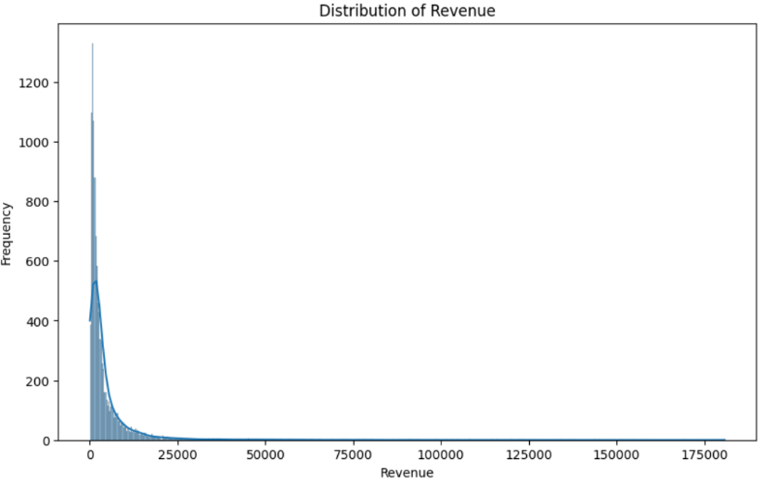

Fig 1. Histogram showing the distribution of revenue across companies, highlighting strong right skewness and the presence of extreme values.
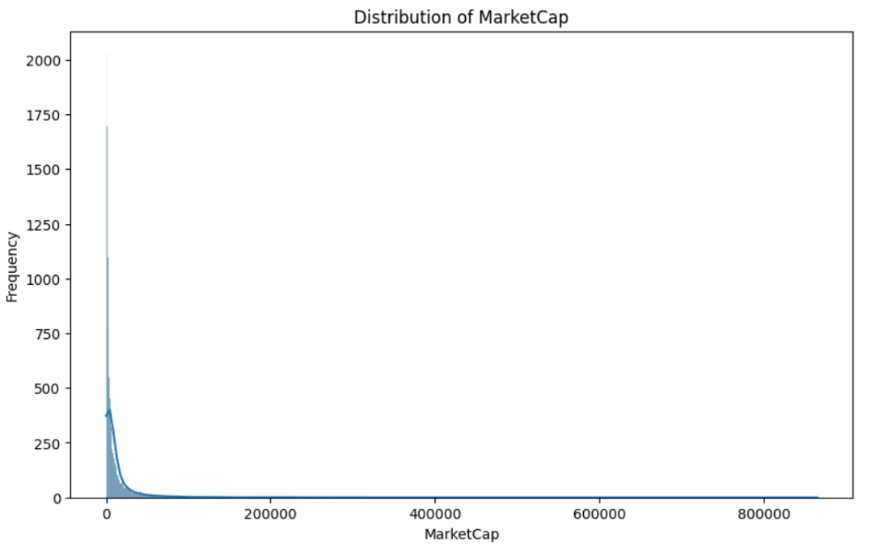

Fig 2. Distribution of market capitalization indicating a highly skewed structure, with a small number of firms accounting for very large market values.

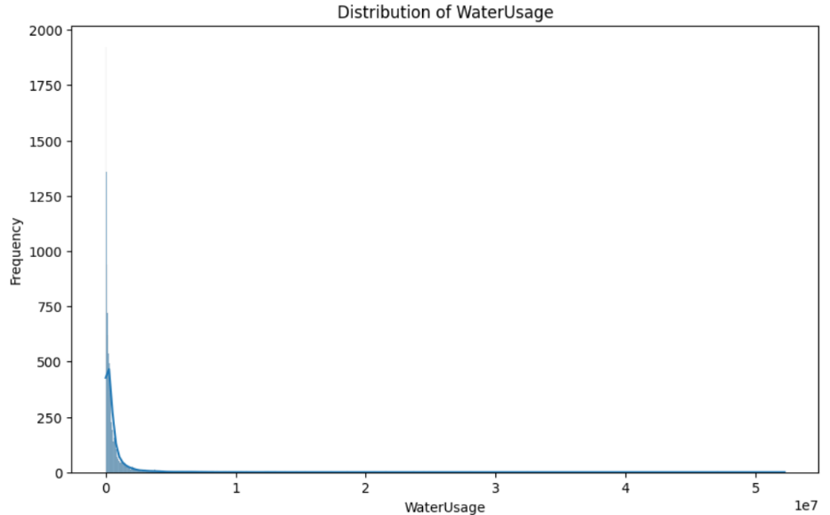

Fig 3. Histogram illustrating the distribution of water usage across firms, showing heavy right skewness and wide variation in resource consumption.

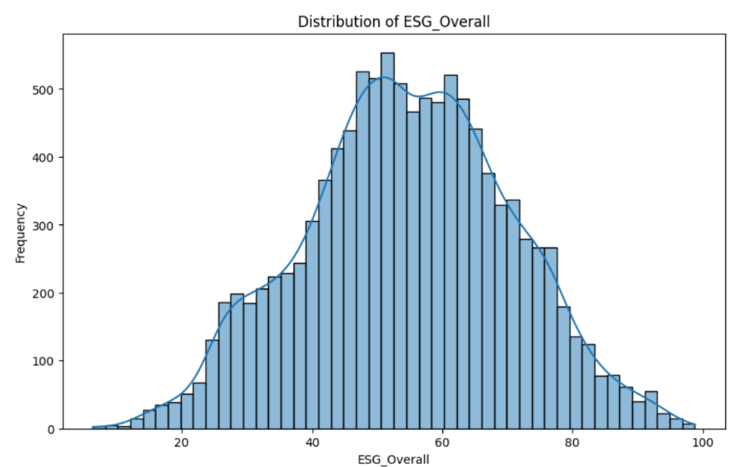

Fig 4. Distribution of overall ESG scores displaying an approximately normal pattern, indicating balanced representation of low, medium, and high ESG performers.

3.2 Bivariate Analysis
Purpose of Bivariate Analysis
Bivariate analysis is conducted to examine the relationship between pairs of variables, particularly between the target variables (Market Capitalization and Market Cap Category) and key financial and ESG predictors. This step helps identify meaningful associations, potential multicollinearity, and early signals of linear or non-linear relationships that inform subsequent model selection and feature engineering.

Revenue vs Market Capitalization
A strong positive relationship is observed between company revenue and market capitalization. Firms with higher revenue levels tend to exhibit significantly higher market valuations. However, the relationship is non-linear, with valuation increases tapering off at very high revenue levels. This suggests diminishing marginal valuation gains as firms grow extremely large, reinforcing the suitability of non-linear and ensemble-based models.

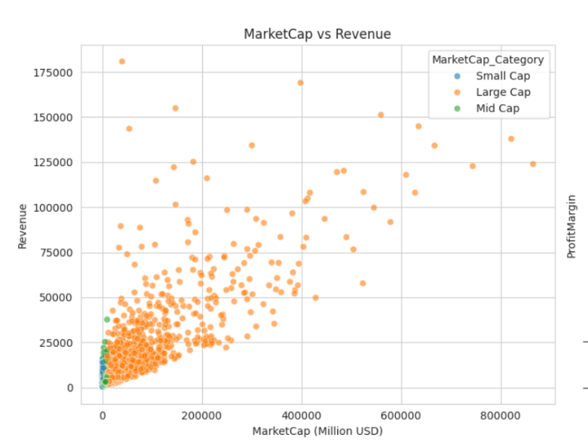

Fig 5. Relationship between Market Capitalization and Revenue across Market Cap Categories

Profit Margin vs Market Capitalization
Profit margin shows a positive but weaker association with market capitalization compared to revenue. While higher margins generally correspond to higher valuations, the dispersion indicates that profitability alone does not fully explain valuation differences. This highlights that scale and growth expectations dominate valuation, with profitability acting as a refinement factor rather than a primary driver.
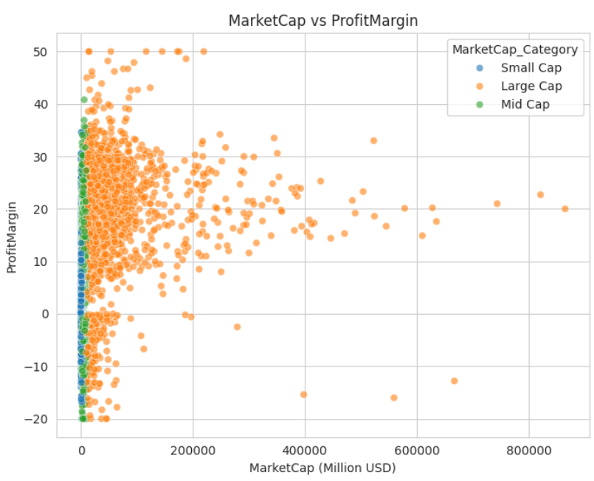

Fig 6. Relationship between Market Capitalization and Profit Margin across Market Cap Categories

Growth Rate vs Market Capitalization
Growth rate demonstrates a moderate positive relationship with market capitalization. Firms exhibiting higher growth rates are often valued at a premium, even when current revenues are relatively modest. This supports the idea that markets price future expectations in addition to present performance.
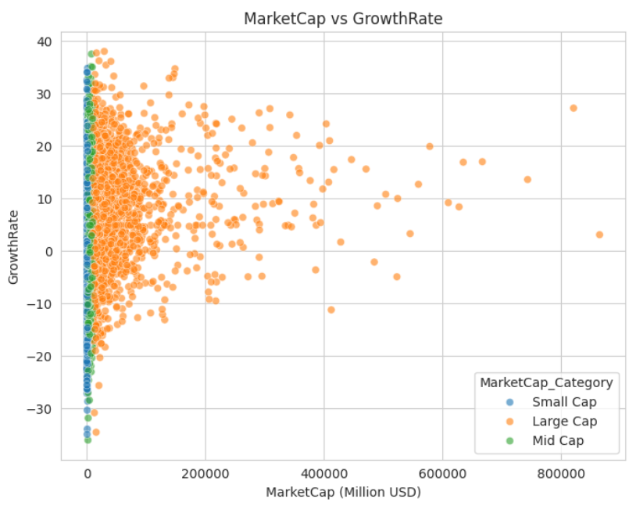

Fig 7. Relationship between Market Capitalization and Growth Rate across Market Cap Categories

ESG Overall Score vs Market Capitalization
The relationship between ESG Overall score and market capitalization is positive but less pronounced than financial variables. Firms with stronger ESG scores tend to cluster at higher valuation levels, though the spread suggests ESG acts as a secondary valuation signal. This supports the use of ESG as a complementary factor rather than a standalone predictor.

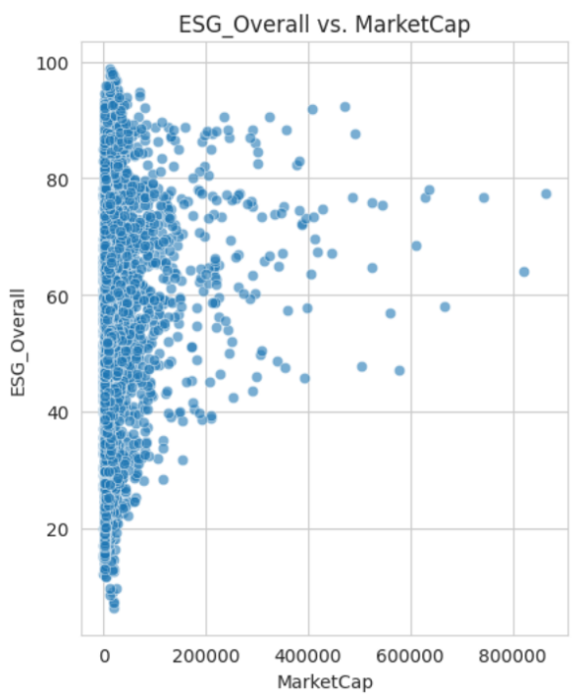

Fig 8. Relationship between ESG Overall Score and Market Capitalization

Water Usage vs Market Capitalization
Water usage shows a weak but meaningful relationship with market capitalization. High water usage is more common among large firms due to scale, but extreme inefficiencies are associated with lower valuations relative to peers. This indicates that resource efficiency, rather than absolute consumption, influences market perception.
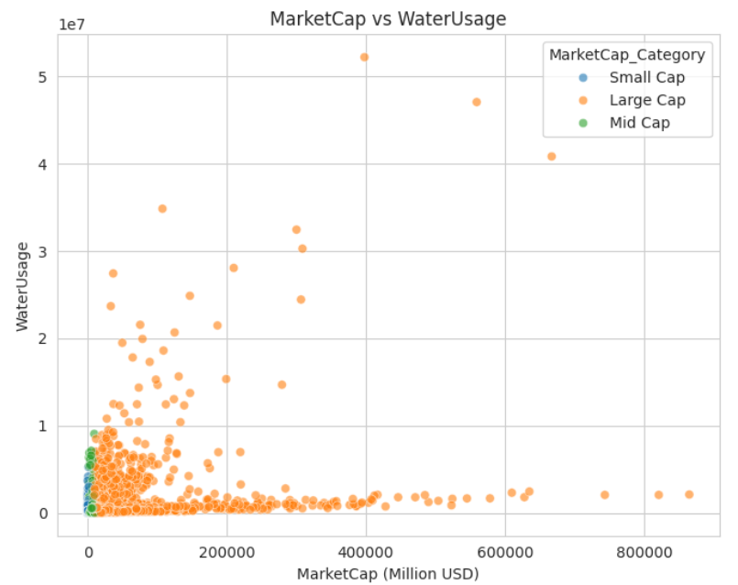

Fig 9. Relationship between Market Capitalization and Water Usage across Market Cap Categories

Industry-wise Differences
Clear valuation differences are observed across industries. Capital-intensive industries tend to exhibit higher revenue and market capitalization, while service-oriented sectors show comparatively lower valuation ranges. This confirms the importance of including industry as a categorical predictor in both regression and classification models.
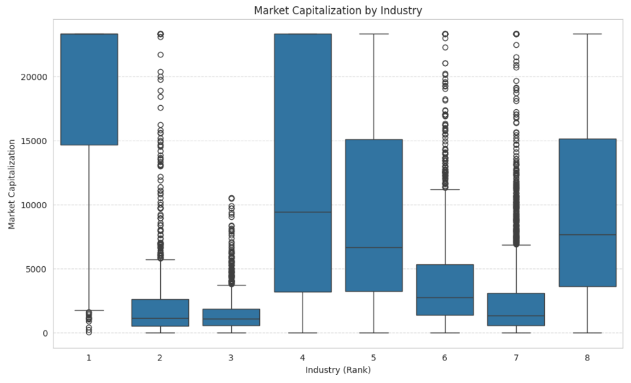

Fig 10. Distribution of MarketCap across Industries

Key Insights from Bivariate Analysis
- Revenue shows the strongest relationship with market capitalization, confirming firm size as the primary driver of valuation.
- Profit margins and growth rates further differentiate valuations, especially among firms of similar scale.
- ESG performance has a positive but secondary influence, enhancing valuation rather than driving it independently.
- Resource usage variables reflect operational efficiency concerns rather than directly explaining firm size.
- Industry context significantly influences valuation patterns, indicating sector-specific valuation dynamics.

Implications for Model Building
The presence of non-linear relationships, heteroscedasticity, and industry-specific effects supports the use of ensemble models (Random Forest, Decision Tree) alongside traditional regression techniques. Additionally, these relationships justify feature selection and transformation steps applied later in the analysis.

3.3 Trends Across Time (2015–2025)
To understand how firm performance and sustainability characteristics evolve over time, a temporal analysis was conducted across the period 2015–2025. This analysis focuses on average trends in key financial and ESG-related variables, providing longitudinal context to complement the univariate and bivariate findings.
The analysis reveals a consistent upward trend in firm revenue over the observed period, indicating sustained growth across companies. This steady increase suggests that, on average, firms have expanded their operational scale over time. The presence of a strong and monotonic revenue trend helps explain why revenue later emerges as the most influential predictor of market capitalization in regression and tree-based models.
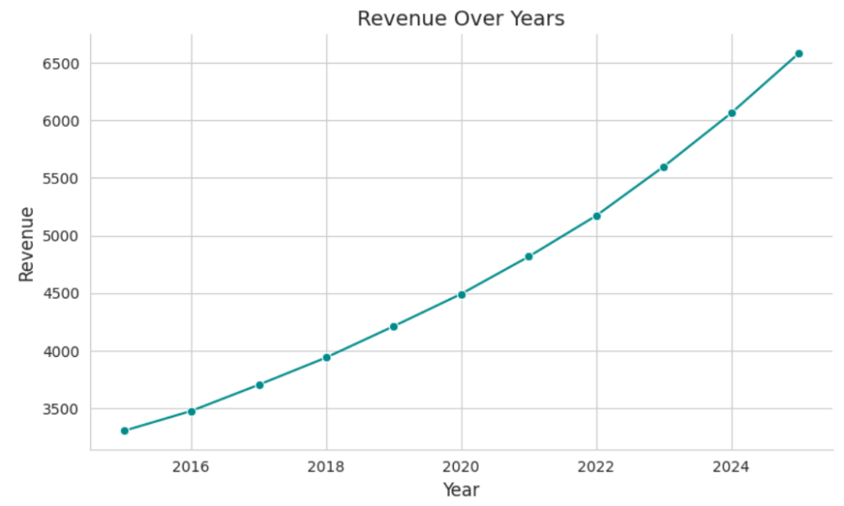

Fig 11. Revenue Growth Trend Across Firms (2015–2025)

A similar upward pattern is observed in market capitalization, reflecting long-term value creation in line with revenue expansion. While short-term fluctuations exist, the overall trajectory indicates that firm valuation has grown steadily over the decade. This reinforces the conceptual linkage between firm scale and valuation and validates the use of market capitalization as a primary outcome variable for both regression and classification tasks.
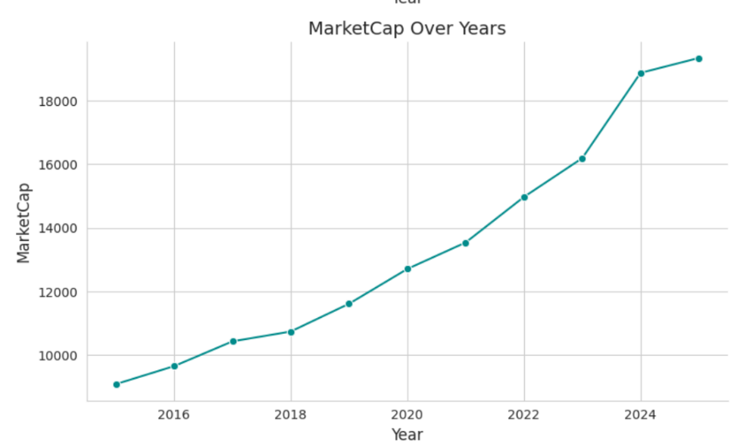

Fig 12. Market Capitalization Trend (2015–2025)

From a sustainability perspective, ESG Overall scores show a gradual but consistent improvement over time. This trend suggests increasing adoption of ESG practices across firms, likely driven by regulatory pressure, investor scrutiny, and evolving corporate governance norms. However, the incremental nature of this improvement indicates that ESG progress is gradual rather than transformative within short time horizons.

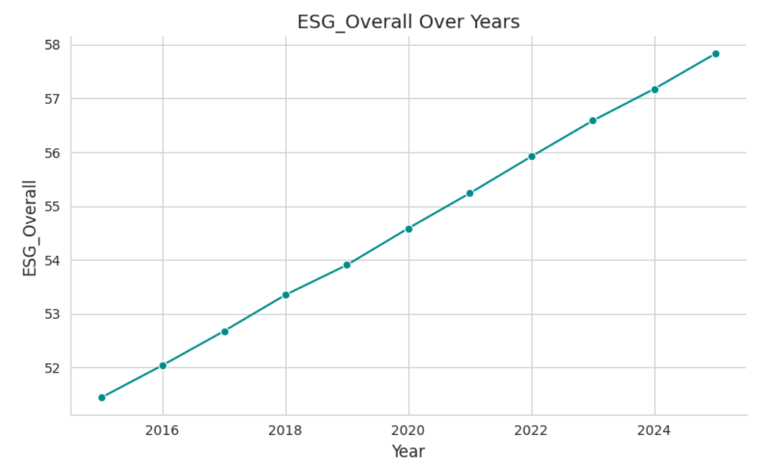

Fig 13. Trend in ESG Overall Scores (2015–2025)

Carbon emissions, water usage, and energy consumption also display rising trends over the same period, largely reflecting increases in firm scale and production intensity. Unlike financial performance indicators, these variables primarily capture operational expansion and resource intensity rather than direct value creation. As a result, environmental resource metrics are better interpreted as indicators of cost structure and efficiency pressures, rather than standalone drivers of market valuation.
Overall, the temporal analysis highlights a clear distinction between growth-driven financial metrics, which show strong and consistent upward movement, and sustainability indicators, which improve more gradually and often scale with firm size. These time-based trends provide important context for the modeling results, particularly in explaining why financial variables dominate valuation predictions while ESG and resource-related factors play a secondary, moderating role.

3.4 Initial Insights from Exploratory Data Analysis
- The exploratory analysis indicates that firm valuation is influenced by a combination of financial scale, performance efficiency, and contextual sustainability factors, rather than any single variable.
- The observed skewness and non-linear patterns in key variables suggest that traditional linear assumptions may not fully capture valuation dynamics.
- Variations across industries and firm sizes highlight the importance of context-aware modeling, particularly when comparing firms operating at different scales.
- Temporal patterns show that while financial metrics grow steadily over time, sustainability indicators evolve more gradually, reinforcing their role as supporting rather than primary valuation signals.
- These characteristics collectively justify the use of both regression-based and tree-based machine learning models, as well as feature transformation and careful model evaluation.
- The EDA confirms that the dataset is suitable for predictive modeling and provides clear guidance for feature selection, transformation, and model choice in subsequent analysis.

4. DATA PREPROCESSING AND FEATURE ENGINEERING

4.1 Handling Missing Values
Prior to model development, the dataset was examined to identify missing or incomplete observations across all variables. This step is essential to ensure data integrity and to prevent bias or instability in model estimation.
The inspection revealed that missing values were present only in the Growth Rate variable, while all other financial, ESG, and categorical variables were complete. Since Growth Rate is an important indicator of firm expansion and future potential, it was necessary to address these missing values rather than remove the affected observations.
To handle the missing values in Growth Rate, median imputation was applied. The median was selected as the imputation measure because growth rates often exhibit skewness and may be influenced by extreme values. Compared to mean imputation, the median provides a more robust estimate of central tendency and reduces the risk of distortion caused by outliers.
No rows were dropped during this process, ensuring that the full set of firm-year observations was retained. This approach preserved both the cross-sectional and temporal structure of the dataset, which is important for subsequent regression and classification analyses.
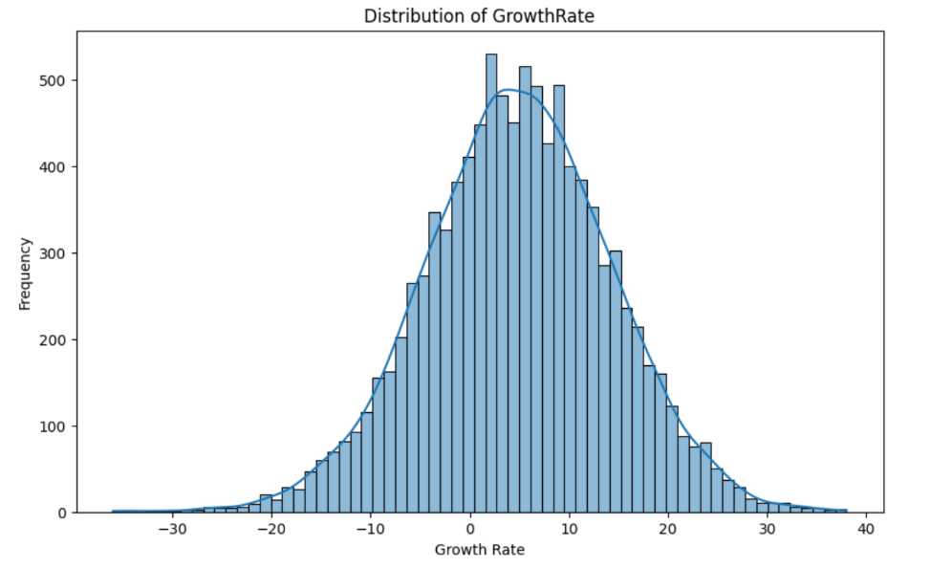
By limiting imputation to a single variable and using a robust statistical method, the preprocessing step ensured that the dataset remained complete, consistent, and suitable for downstream modeling without introducing unnecessary assumptions.

Fig 14. Distribution of Growth Rate Before Missing Value Imputation
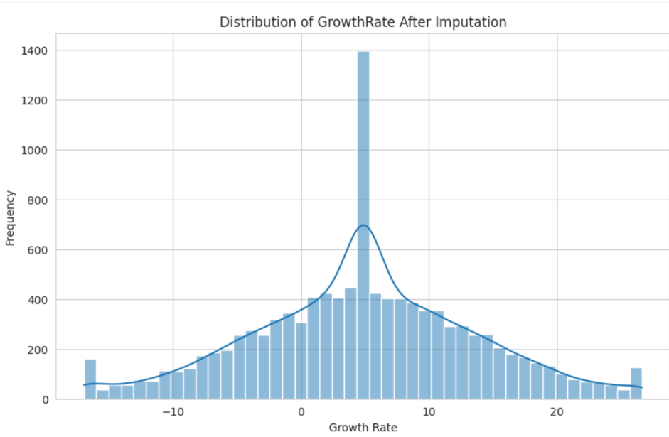

Fig 15. Distribution of Growth Rate After Median Imputation

4.2 Outlier Detection and Treatment
Outlier detection was conducted across all key numerical variables to identify extreme observations that could disproportionately influence model performance. Box plots were used as the primary diagnostic tool to visually assess the presence, spread, and severity of outliers in financial, growth, and ESG-related variables.
The analysis revealed significant outliers across nearly all continuous variables, including Revenue, Market Capitalization, Profit Margin, Growth Rate, ESG scores, Carbon Emissions, Water Usage, and Energy Consumption. These outliers were particularly pronounced in scale-driven variables such as revenue, market capitalization, and environmental resource usage, reflecting the heterogeneous nature of firm size, industry characteristics, and operational intensity in the dataset.
Given the high degree of skewness and the presence of extreme values, outlier treatment was applied to all numerical variables, including Market Capitalization, to improve model stability and predictive reliability. Although Market Capitalization serves as the target variable, extreme values in the target can disproportionately influence loss functions in regression models and bias decision boundaries in classification tasks. Without treatment, a small number of extremely large firms could dominate model learning, reducing generalizability for the majority of observations.
Outlier treatment was implemented using winsorization (statistical capping) based on distribution-aware thresholds rather than outright removal of observations. This approach preserves all firms in the dataset while constraining extreme values within economically reasonable bounds. As a result, the relative ranking and scale differences between firms are maintained, while excessive leverage from extreme observations is mitigated.
Post-treatment box plots show a substantial reduction in extreme dispersion, particularly for Market Capitalization, Revenue, and environmental resource variables. The resulting distributions exhibit improved compactness and reduced variance, making them more suitable for both regression and classification algorithms. Importantly, this treatment enhances numerical stability while retaining meaningful variation across firm sizes.
By treating outliers consistently across both predictor and target variables, the preprocessing pipeline ensures balanced model learning, improved convergence, and fair comparison across algorithms. This step was essential in enabling robust valuation modeling without sacrificing economic interpretability or dataset realism.
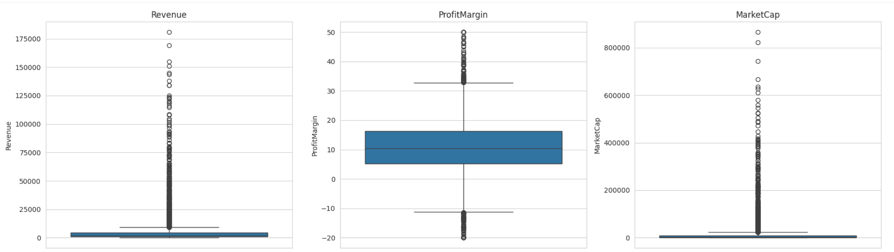
Fig16. Boxplots of Key Financial Variables Before Outlier Treatment

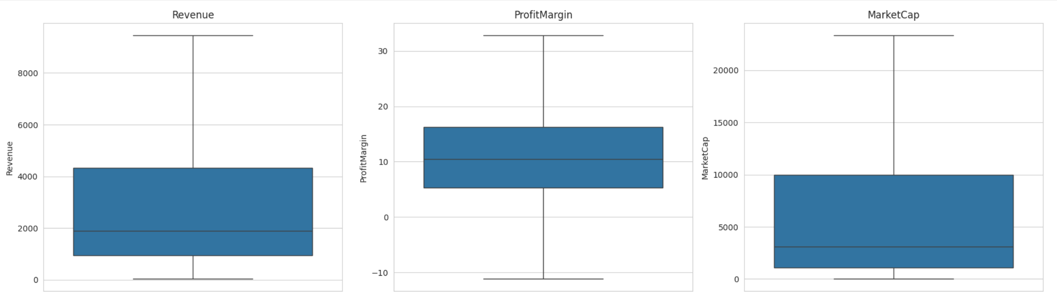
Fig17. Boxplots of Key Financial Variables After Outlier Treatment

4.3 Transformation of Categorical Variables
The dataset contains two categorical variables—Industry and Region—which were incorporated into the modeling framework through a transformation approach rather than conventional categorical encoding techniques.
Instead of applying one-hot encoding or label encoding, both variables were transformed using a frequency-based ordinal ranking method. Specifically, the number of observations within each industry and region category was computed, and categories were assigned dense ranks based on their relative frequency in the dataset. These ranks were then mapped back to the original categorical values to generate numeric representations.
This approach was intentionally selected to preserve relative prevalence information while avoiding the dimensionality expansion associated with one-hot encoding. Given the large number of industry and region categories, traditional encoding would have significantly increased the feature space, potentially introducing sparsity and reducing model interpretability.
Additionally, frequency-based ranking provides a meaningful ordering that reflects market representation and exposure, which is particularly relevant in valuation-related modeling. Industries and regions with higher representation often correspond to more established markets, making this transformation economically interpretable rather than purely technical.
Importantly, this transformation treats the resulting variables as ordinal proxies rather than nominal identifiers. This makes them suitable for use across both regression-based and tree-based models without imposing artificial distance assumptions or inflating feature importance.
By adopting this transformation strategy, categorical information was retained in a compact and interpretable form, ensuring consistency with the overall modeling objectives while maintaining computational efficiency and robustness.

4.4 Feature Scaling and Transformation
Feature scaling was applied selectively based on the assumptions and sensitivity of the modeling techniques used in this study. Rather than adopting a uniform scaling strategy across all models, scaling decisions were guided by the mathematical properties of each algorithm to ensure methodological correctness and interpretability.
For linear regression–based models, including Multiple Linear Regression (MLR), Ridge Regression, and LASSO Regression, standardization using StandardScaler was performed. These models are sensitive to the scale of input variables, as coefficient estimation and regularization penalties depend on feature magnitudes. Standardization ensured that all continuous predictors were transformed to a common scale with zero mean and unit variance, enabling meaningful coefficient comparison and stable convergence during model training.
In contrast, tree-based models—namely Decision Tree, Random Forest, Gradient Boosting, and XGBoost—were trained without feature scaling. These algorithms rely on recursive threshold-based splits and are invariant to monotonic transformations of the input variables. As a result, scaling does not influence their performance or interpretability. Avoiding unnecessary scaling for these models preserved the original data distribution and reduced preprocessing complexity.
No additional nonlinear transformations (such as logarithmic or power transformations) were applied at this stage, as prior outlier treatment and winsorization had already addressed extreme skewness in key variables. This ensured that the feature space remained consistent and comparable across different modeling approaches.
Overall, the selective application of feature scaling improved model validity by aligning preprocessing choices with algorithmic requirements, while maintaining consistency between regression and tree-based learning frameworks.

4.5 Train–Test Split Strategy
To ensure an unbiased evaluation of model performance, the dataset was partitioned into training and testing subsets using a consistent train–test split strategy across both regression and classification tasks. The split was implemented using the train_test_split function from the scikit-learn library.
Across all modeling approaches, 80% of the data was allocated to the training set and 20% to the testing set, with a fixed random seed (random_state = 42) to ensure reproducibility of results. This proportion provides sufficient data for model learning while retaining an adequate hold-out sample for reliable performance assessment.
For linear regression–based models (Multiple Linear Regression, Ridge Regression, and LASSO Regression), the train–test split was performed prior to feature scaling. Standardization was then applied only on the training data, and the same transformation was used on the test data. This sequence prevents information leakage from the test set into the training process and ensures valid coefficient estimation.
In contrast, for tree-based and ensemble models (Decision Tree, Random Forest, Gradient Boosting, and XGBoost), the train–test split was applied directly to the original feature space without scaling. This is methodologically appropriate, as tree-based algorithms are invariant to feature scale and rely on hierarchical splitting rather than distance-based optimization.
By maintaining a consistent split ratio and random seed while allowing preprocessing steps to vary according to algorithmic requirements, the train–test strategy supports fair model comparison, robust generalization assessment, and methodological rigor across all experiments conducted in this study.

5. REGRESSION ANALYSIS: MARKET CAPITALIZATION PREDICTION

5.1 Regression Problem Formulation
The objective of the regression analysis is to predict firm-level market capitalization as a continuous variable using a combination of financial performance metrics, growth indicators, ESG scores, environmental resource usage measures, and contextual firm characteristics. Market capitalization serves as a comprehensive proxy for firm valuation, reflecting both current performance and investor expectations regarding future growth and risk.
Formally, the regression problem is defined as estimating a functional relationship between Market Capitalization (dependent variable) and a set of explanatory variables that capture multiple dimensions of firm behavior. These predictors include revenue, profit margin, growth rate, ESG performance scores, carbon emissions, water usage, energy consumption, industry classification, regional presence, and temporal effects. Together, these variables represent a holistic view of firm scale, efficiency, sustainability practices, and operating environment.
From a business perspective, predicting market capitalization is highly relevant for investors, financial analysts, and policymakers. Accurate valuation estimates enable improved investment screening, portfolio allocation, peer comparison, and risk assessment. Unlike classification approaches that group firms into discrete size categories, regression modeling preserves the continuous nature of valuation, allowing for more granular insights into how incremental changes in firm characteristics translate into changes in market value.
The regression task also supports analytical interpretability. By modeling market capitalization as a function of observable firm attributes, the analysis enables examination of which factors materially drive valuation and the relative strength of their influence. This is particularly important in the context of ESG integration, where the extent to which sustainability metrics contribute to firm value remains an active area of academic and business inquiry.
Overall, this regression framework is designed not only to achieve predictive accuracy but also to generate economically meaningful insights that can inform valuation strategies and corporate decision-making.

5.2 Models Considered
To address the market capitalization prediction task, multiple regression models were considered to capture both linear and non-linear relationships between firm characteristics and valuation. The use of diverse modeling approaches enables a comprehensive evaluation of predictive performance while balancing interpretability and flexibility.
The first set of models consists of linear regression–based techniques, including Multiple Linear Regression (MLR), Ridge Regression, and LASSO Regression. Multiple Linear Regression serves as a baseline model, offering transparent coefficient-based interpretation of how individual predictors relate to market capitalization. Ridge and LASSO regressions extend this framework by introducing regularization, which helps mitigate multicollinearity and overfitting. Ridge regression applies L2 regularization to shrink coefficients smoothly, while LASSO regression applies L1 regularization, enabling implicit feature selection by driving less informative coefficients toward zero.
To capture potential non-linearities and interaction effects that linear models may fail to represent, several tree-based and ensemble regression models were also evaluated. These include the Decision Tree Regressor, Random Forest Regressor, Gradient Boosting Regressor, and XGBoost Regressor. Decision Trees model valuation through hierarchical splits, allowing for intuitive rule-based interpretation. Random Forest improves upon this by aggregating multiple trees trained on bootstrapped samples, reducing variance and improving generalization. Gradient Boosting and XGBoost further enhance predictive performance by sequentially correcting residual errors, making them particularly effective in complex, high-dimensional settings.
These models were selected to reflect varying assumptions about data structure and complexity. Linear models emphasize interpretability and global relationships, while tree-based and ensemble models prioritize predictive accuracy and robustness to non-linear patterns and interactions. Evaluating this diverse set of regression techniques allows for a rigorous comparison and supports informed selection of the most suitable model for market capitalization prediction.

5.3 Model Evaluation Metrics
To evaluate and compare the performance of the regression models, multiple evaluation metrics were employed. Using a combination of metrics allows for a balanced assessment of predictive accuracy, error magnitude, and model reliability, particularly when modeling firm valuation.
The primary metric used is the Coefficient of Determination (R²), which measures the proportion of variance in market capitalization explained by the model. R² provides an overall indication of model fit and is useful for comparing explanatory power across different regression techniques. However, as R² alone does not capture prediction error magnitude, it was interpreted alongside error-based metrics.
To assess prediction accuracy in absolute terms, Mean Absolute Error (MAE) was used. MAE represents the average absolute difference between predicted and actual market capitalization values, making it easy to interpret and less sensitive to extreme errors. This metric is particularly relevant from a business perspective, as it reflects the typical deviation of predictions from observed valuations.
In addition, Root Mean Squared Error (RMSE) was employed to capture the impact of larger prediction errors. RMSE penalizes larger deviations more heavily than MAE, making it useful for identifying models that occasionally produce substantial misestimations. Given the presence of high-value firms in the dataset, RMSE serves as an important indicator of model robustness.
Together, R², MAE, and RMSE provide a comprehensive evaluation framework. While R² assesses explanatory strength, MAE and RMSE evaluate practical prediction accuracy. Using these metrics in combination ensures that model selection is based not only on statistical fit but also on real-world relevance and generalization performance.

5.4 Comparative Performance of Regression Models
A comparative evaluation was conducted across linear, regularized, and tree-based regression models to assess their effectiveness in predicting market capitalization. Model performance was assessed on the test dataset using R², RMSE, and MAE to ensure comparability and generalization validity.
Among the linear models, Linear Regression and Ridge Regression exhibited nearly identical performance, with test R² values of approximately 0.65 and RMSE close to 0.89. This indicates that regularization did not materially improve predictive power, suggesting limited multicollinearity effects in the feature set. Lasso Regression performed slightly worse, with a lower R² and higher error values, reflecting coefficient shrinkage that may have removed informative predictors.
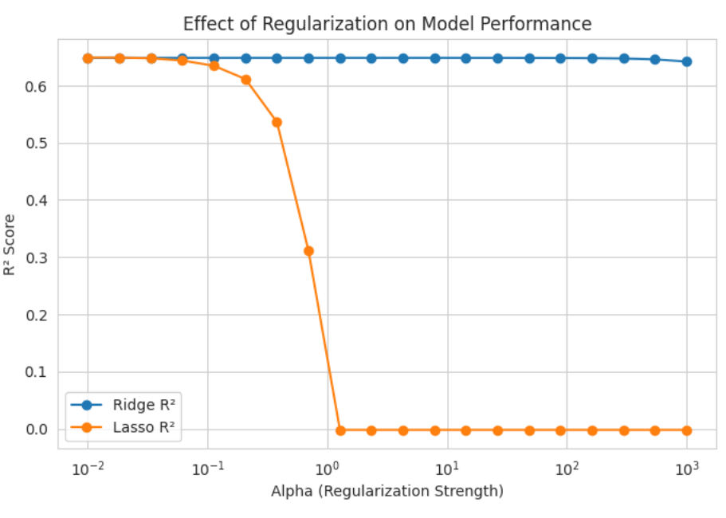

Fig18. Effect of Regularization on Ridge vs Lasso (Alpha vs R² plot)

In contrast, tree-based models significantly outperformed linear approaches. The Decision Tree model achieved a strong test R² of approximately 0.89, indicating its ability to capture nonlinear relationships. Performance improved further with ensemble methods.
Random Forest and Gradient Boosting emerged as the top-performing models, both achieving test R² values close to 0.96, with substantially lower RMSE and MAE compared to all other models. XGBoost also delivered strong performance, though marginally below Random Forest and Gradient Boosting.
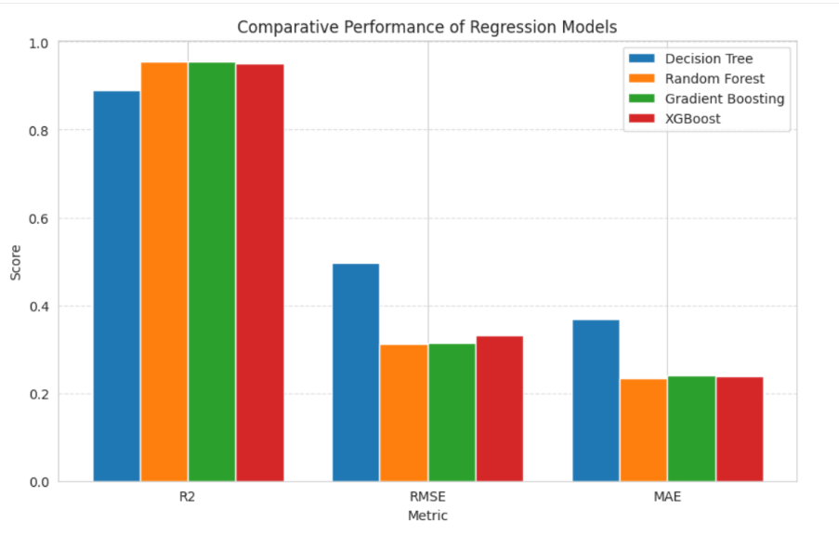

Fig19. Comparative Performance of Regression Models (R², RMSE, MAE bar chart)

Overall, the comparison demonstrates a clear hierarchy in model effectiveness:
- Linear and regularized models provide baseline interpretability but limited predictive accuracy.
- Tree-based and ensemble models substantially enhance performance by capturing nonlinear interactions and complex feature dependencies.
These findings justify the selection of an ensemble-based model for final deployment and interpretation.

5.5 Selection of the Best Regression Model
Based on the comparative evaluation of all regression models, Random Forest Regression was selected as the final and best-performing model for market capitalization prediction.
The selection was driven primarily by superior test-set performance. The Random Forest model achieved a test R² of approximately 0.96, indicating that it explains a very high proportion of the variance in market capitalization. In addition, it recorded the lowest RMSE and MAE among all evaluated models, reflecting both high predictive accuracy and low average prediction error on unseen data.
Beyond performance metrics, Random Forest demonstrates strong robustness to non-linearity and outliers, which is particularly important given the skewed distributions and heterogeneous scale of financial and ESG variables in the dataset. Unlike linear and regularized regression models, it does not rely on strict assumptions such as linear relationships or normally distributed residuals, making it better suited for complex, real-world firm-level data.
Although Gradient Boosting and XGBoost also exhibited strong predictive capability, Random Forest was preferred due to its slightly better balance between accuracy, stability, and interpretability. The ensemble averaging mechanism inherent in Random Forest reduces variance and limits overfitting, which is supported by the close alignment between training and test performance metrics observed in the results.
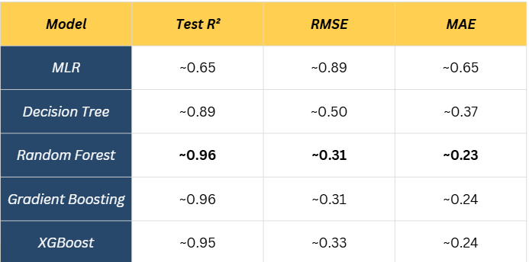
Overall, Random Forest Regression was selected as the final regression model as it provides the most reliable, accurate, and generalizable approach for predicting market capitalization in the context of this study.

Fig20. Comparative Test Performance of Regression Models for Market Cap Prediction

5.6 Interpretation of the Final Regression Model
Based on the comparative evaluation conducted in the previous section, the Random Forest regression model was selected as the final model for predicting market capitalization. This section focuses on interpreting the behavior of the selected model and understanding how it learns relationships between financial, operational, and ESG-related variables.
The Random Forest model captures non-linear relationships and interaction effects among predictors, which are common in real-world financial data. Unlike linear models that assume additive and proportional effects, the ensemble structure of Random Forest allows the model to account for complex dependencies between firm scale, profitability, industry context, and resource usage. This capability explains the substantial improvement in predictive accuracy over linear and regularized regression approaches.
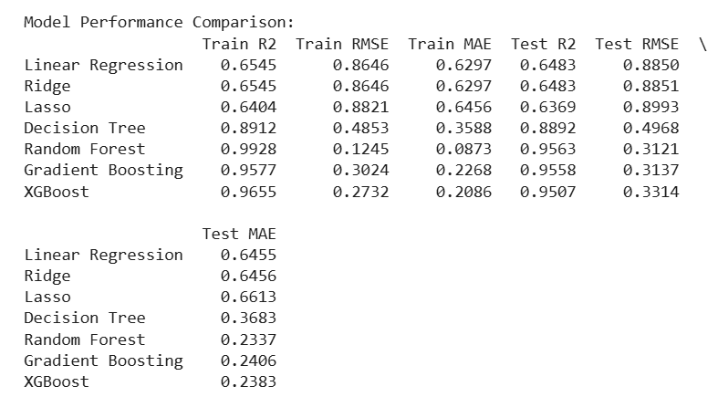

Fig21. Comparative Training and Testing Performance of Regression Models

From a predictive standpoint, the model demonstrates strong generalization performance, as evidenced by a high test R² and low error metrics. The close alignment between training and test performance indicates that the model avoids overfitting despite its flexibility. This stability is particularly important given the wide dispersion in variables such as revenue, market capitalization, and environmental resource usage.
Interpretation of the Random Forest model also reveals that financial scale variables dominate valuation prediction, while sustainability and operational variables act as secondary refiners. The model does not treat ESG metrics or resource usage as isolated drivers of valuation; instead, their influence is conditional on firm size and industry context. This behavior aligns with real-world valuation logic, where sustainability performance enhances credibility and long-term resilience rather than directly determining market value.
Overall, the final regression model provides a balanced and realistic representation of firm valuation dynamics. It effectively integrates traditional financial indicators with ESG and operational signals, producing predictions that are both accurate and economically interpretable. This makes the model suitable not only for predictive purposes but also for strategic insight generation in investment and corporate analysis contexts.
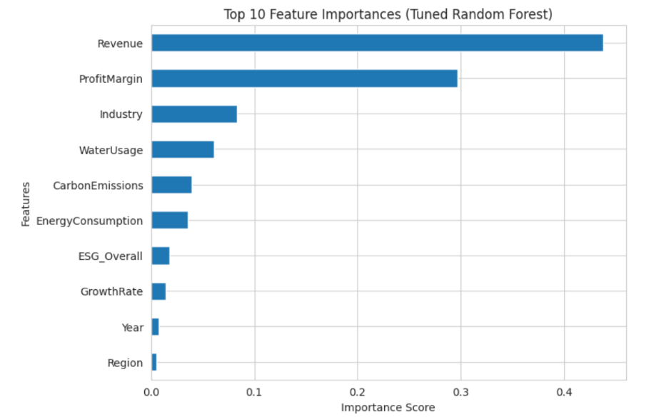

Fig22. Top Feature Importances from the Tuned Random Forest Regression Model

5.7 Feature Importance and Business Meaning
• Revenue is the most influential feature in the model, indicating that firm scale is the primary driver of market capitalization. Higher revenues signal market presence, operational scale, and long-term earning capacity, making revenue a strong proxy for firm valuation.
• Profit Margin is the second most important predictor, highlighting that profitability significantly differentiates firm valuation beyond size alone. Firms with efficient cost structures and stronger margins tend to command higher market capitalization even at comparable revenue levels.
• Industry plays a meaningful role in valuation, reflecting sector-specific growth potential, capital intensity, and risk profiles. This confirms that valuation dynamics vary across industries and supports the inclusion of industry context in predictive modeling.
• Water Usage, Carbon Emissions, and Energy Consumption show moderate importance, primarily capturing operational scale and efficiency. These variables act as indirect indicators of production intensity, regulatory exposure, and sustainability-related costs rather than direct valuation drivers.
• ESG Overall contributes positively but remains secondary to financial variables. This suggests that sustainability performance enhances firm valuation when financial fundamentals are strong, acting as a qualitative differentiator rather than a dominant factor.
• Growth Rate has relatively lower importance, indicating that short-term growth fluctuations contribute less to valuation once revenue scale and profitability are accounted for.
• Year and Region exhibit minimal influence in the final model, suggesting that temporal variation and geographic location have limited incremental explanatory power after controlling for firm-specific financial and ESG characteristics.

6. Classification Methodology

6.1. Objective of Classification
The objective of this classification analysis is to categorize companies into Small-Cap, Mid-Cap, and Large-Cap segments using financial and ESG-related indicators. This classification helps in understanding how sustainability and financial performance jointly influence firm valuation and market positioning.

6.2 Market Capitalization Classification Framework
- Target Variable Definition
The target variable for the classification task is MarketCap_Category, which represents a categorical segmentation of companies based on industry-standard market capitalization thresholds. The three classes are defined as:
- Small Cap
- Mid Cap
- Large Cap
This transformation converts the problem into a multi-class supervised classification task.
- Feature Selection and Data Leakage Prevention
To ensure valid and unbiased model training, MarketCap was excluded from the feature set, as it is directly used to derive the target variable. Including it would result in data leakage and artificially inflated performance.
Additionally, individual ESG pillar scores (ESG_Environmental, ESG_Social, ESG_Governance) were excluded from the classification features. Prior variance inflation factor (VIF) analysis revealed strong multicollinearity between these variables and the composite ESG_Overall score. To avoid redundancy and instability in model estimation, only ESG_Overall was retained as a representative sustainability indicator.
- Feature Set for Classification
The final feature set includes:
- Financial variables: Revenue, Profit Margin, Growth Rate
- Sustainability indicator: ESG_Overall
- Resource usage metrics: Carbon Emissions, Water Usage, Energy Consumption
- Contextual variables: Industry, Region, Year
These variables jointly capture firm size, operational performance, sustainability practices, and sectoral context.
- Train–Test Split Strategy
The dataset was divided into training and testing subsets using an 80:20 split. A stratified sampling strategy was applied based on the target variable to ensure that each market capitalization category is proportionally represented in both sets.
This approach is particularly important in multi-class classification problems to prevent biased learning due to class imbalance.
- Data Preprocessing
Categorical variables were encoded into numerical format to ensure compatibility with machine learning algorithms. Feature scaling was applied using StandardScaler for models that are sensitive to feature magnitude and distance calculations, such as Logistic Regression, K-Nearest Neighbors, and Support Vector Machines.
Tree-based models, such as the Decision Tree Classifier, were trained on unscaled data, as they are invariant to feature scaling.

6.3 Classification Models Employed
To ensure a robust and comparative analysis, multiple classification algorithms were implemented:
- Multinomial Logistic Regression
- K-Nearest Neighbors (KNN)
- Support Vector Machine (SVM)
Implemented with multiple kernels (Linear, Polynomial, RBF, Sigmoid) to model both linear and non-linear decision boundaries.
- Decision Tree Classifier (DTC)

6.3.1 Multinomial Logistic Regression – Interpretation & Insights
- Multinomial Logistic Regression was used as a baseline classification model to predict Small, Mid, and Large Cap categories based on financial and ESG-related variables.
- The model achieved an overall accuracy of 0.80, indicating a strong baseline ability to classify firms into appropriate market-cap categories.
- Macro Precision (0.80) shows that the model makes balanced predictions across all classes, without being overly biased toward any single market-cap group.
- Macro Recall (0.79) is slightly lower, suggesting some difficulty in correctly identifying all observations—particularly for Mid Cap firms, where financial characteristics often overlap with Small and Large Caps.
- The Macro F1-score (0.80) confirms a good balance between precision and recall, indicating consistent classification performance.
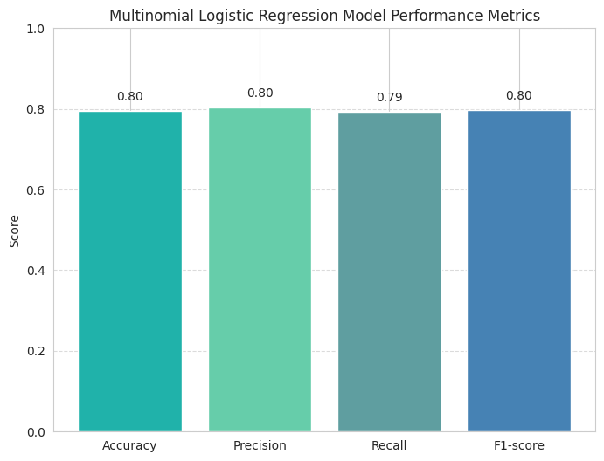
- From a business standpoint, the model is useful for broad market segmentation and offers high interpretability through class probabilities.
- However, due to its linear decision boundaries, the model is less effective at capturing non-linear relationships, motivating the use of advanced models such as SVMs and Decision Trees in subsequent analysis.

6.3.2 K-Nearest Neighbors (KNN) – Interpretation & Insights
- The KNN model was applied to classify firms into Small, Mid, and Large Cap categories based on proximity to similar firms in the feature space.
- The model achieved an overall accuracy of (0.80), indicating performance comparable to Multinomial Logistic Regression.
- Macro Precision (0.80) suggests that predictions across all three market-cap categories are fairly balanced, with limited class bias.
- Macro Recall (0.80) indicates that the model is able to correctly identify a high proportion of firms from each category.
- The Macro F1-score (0.80) confirms consistent classification performance, balancing both false positives and false negatives
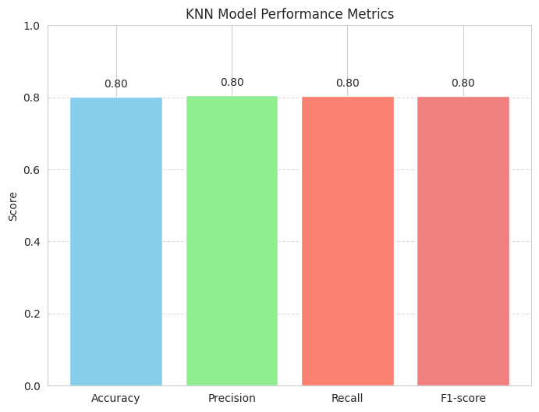
- KNN effectively captures local similarity patterns among firms but is sensitive to feature scaling and noise, which can affect classification stability.
- From a business perspective, KNN works well for peer-group based classification, but its lack of interpretability and sensitivity to data size make it less suitable as a final model.

6.3.3 Support Vector Machine (SVM) – Kernel-wise Analysis
- RBF kernel consistently outperforms all other kernels across evaluation metrics, achieving approximately Accuracy 0.83, Precision 0.83, Recall 0.83, and F1-score 0.83, indicating strong and balanced classification performance.

- Polynomial kernel shows the second-best performance with scores around 0.81–0.82, suggesting it captures moderate non-linear relationships but is less flexible than RBF.
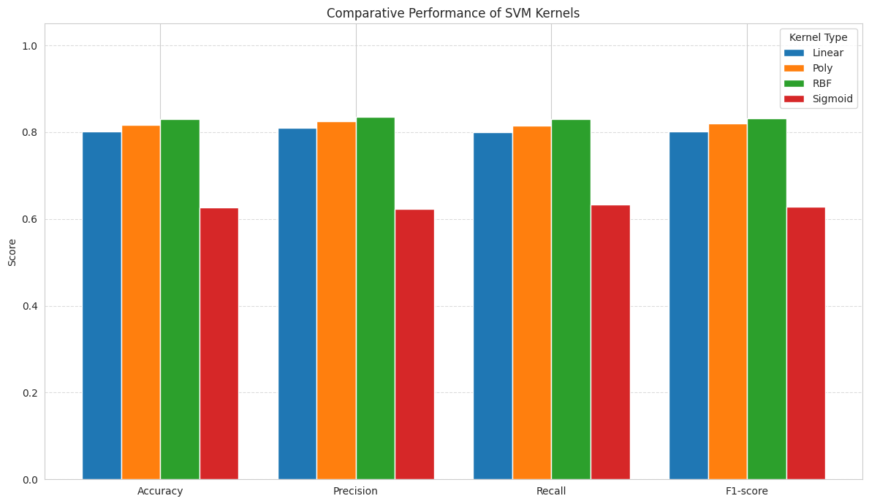

- Linear kernel performs comparably to baseline models (Accuracy ~0.80), confirming that purely linear boundaries are insufficient to fully separate market-cap categories.

- Sigmoid kernel performs poorly across all metrics (0.62–0.63), indicating weak class separation and instability for this dataset.

- The gap between precision and recall is minimal for RBF and Polynomial kernels, reflecting stable classification with low bias toward any specific market-cap class.

6.3.3.1 SVM with RBF Kernel
Among the various Support Vector Machine (SVM) kernels evaluated, the Radial Basis Function (RBF) kernel demonstrated the strongest overall performance for market capitalization classification.
The superior performance of the RBF kernel can be attributed to its ability to capture non-linear relationships between financial indicators, ESG metrics, and firm size. Unlike linear and polynomial kernels, the RBF kernel adapts to complex decision boundaries, which are characteristic of financial datasets where market capitalization is influenced by multiple interacting factors.
Class-wise Performance Analysis
Large Cap
- Precision: 0.89, Recall: 0.85
For Large Cap firms, the model correctly classified 469 out of 549 observations, corresponding to a recall of 0.85. Only 76 Large Cap firms were misclassified as Mid Cap, and 4 were misclassified as Small Cap, indicating that the model reliably identifies large, mature firms with minimal extreme errors. This is further supported by a high precision of 0.89, suggesting that predictions labeled as Large Cap are largely accurate.
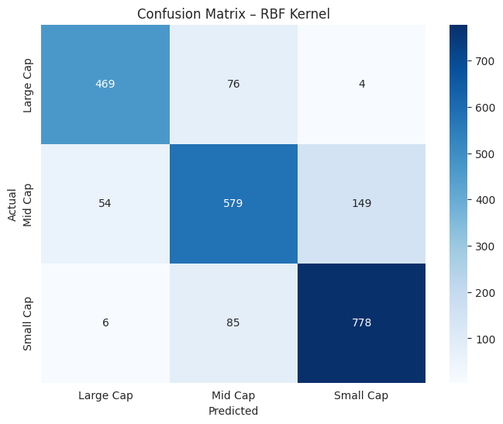
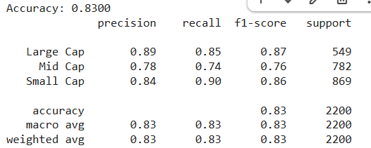
Mid Cap
- Precision: 0.78, Recall: 0.74
- In the case of Mid Cap firms, 579 out of 782 firms were correctly classified, yielding a recall of 0.74. A notable portion of Mid Cap firms were misclassified as Small Cap (149 cases) or Large Cap (54 cases). This reflects the inherent ambiguity of the Mid Cap segment, as these firms often share financial and growth characteristics with both adjacent categories. Consequently, Mid Cap classification remains the most challenging, both statistically and economically.
Small Cap
- Precision: 0.84, Recall: 0.90
- For Small Cap firms, the model achieved particularly strong results, correctly identifying 778 out of 869 firms, corresponding to a high recall of 0.90. Only 85 Small Cap firms were misclassified as Mid Cap, and just 6 were misclassified as Large Cap, demonstrating that extreme misclassification is rare. The high precision of 0.84 further confirms that Small Cap predictions are reliable.

6.3.4 Decision Tree Classifier
- The baseline Decision Tree Classifier achieves an overall accuracy of 86%, with macro-averaged precision (0.86), recall (0.86), and F1-score (0.86)
- The close alignment of accuracy, precision, recall, and F1-score indicates balanced performance across all market-cap categories, without strong bias toward any single class.
- This consistency suggests that the model generalizes reasonably well and does not rely on chance or class imbalance.
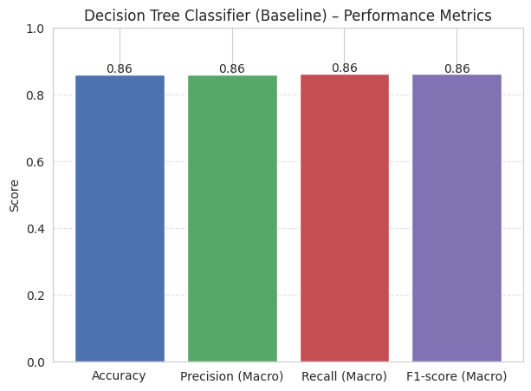

Confusion Matrix Interpretation

1. Large Cap Firms
- 493 out of 549 Large Cap companies are correctly classified.
- Only 55 Large Cap firms are misclassified as Mid Cap, and just 1 as Small Cap.
- This reflects strong precision and recall for Large Cap, meaning the model reliably identifies large, well-established firms.

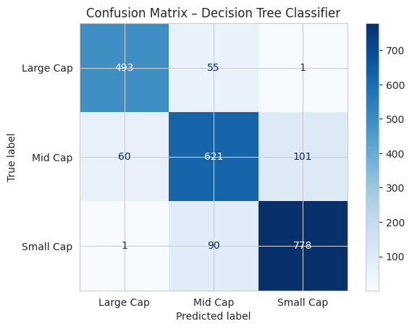

2. Mid Cap Firms
- 621 out of 782 Mid Cap firms are correctly classified.
- Misclassifications mainly occur toward neighboring categories:
  - 60 Mid Cap firms predicted as Large Cap
  - 101 Mid Cap firms predicted as Small Cap
- This indicates that Mid Cap firms are the hardest to classify, as they naturally lie between growth-oriented Small Caps and mature Large Caps.

3. Small Cap Firms
- 778 out of 869 Small Cap companies are correctly identified.
- Only 1 Small Cap firm is misclassified as Large Cap, while 90 are misclassified as Mid Cap.
- The model shows very high recall for Small Cap firms, meaning very few genuinely small companies are missed.

6.4 Evaluation Metrics Used
To capture both overall accuracy and class-wise balance, the following metrics were used:
- Accuracy – Overall correctness of predictions
- Precision (Macro) – How reliable predictions are across classes
- Recall (Macro) – Ability to correctly identify each market-cap category
- F1-score (Macro) – Balance between precision and recall
Macro-averaging was chosen to treat Small, Mid, and Large Cap firms equally, avoiding dominance by majority classes.

6.5 Model Evaluation and Comparative Analysis (Before Tuning)
The table summarizes the performance of all classification models evaluated for market capitalization categorization using Accuracy, Precision (Macro), Recall (Macro), and F1-Score (Macro). These metrics were selected to ensure balanced evaluation across Small, Mid, and Large Cap classes.

Key Findings from Model Evaluation
- Logistic Regression achieved an accuracy of approximately 80%, indicating reasonable baseline performance. However, its linear nature limits its ability to capture complex, non-linear relationships in financial and ESG variables.
- K-Nearest Neighbors (KNN) slightly outperformed Logistic Regression with an accuracy of 81%, benefiting from local similarity-based classification. Performance remains consistent across precision, recall, and F1-score, but KNN is sensitive to data scaling and noise.
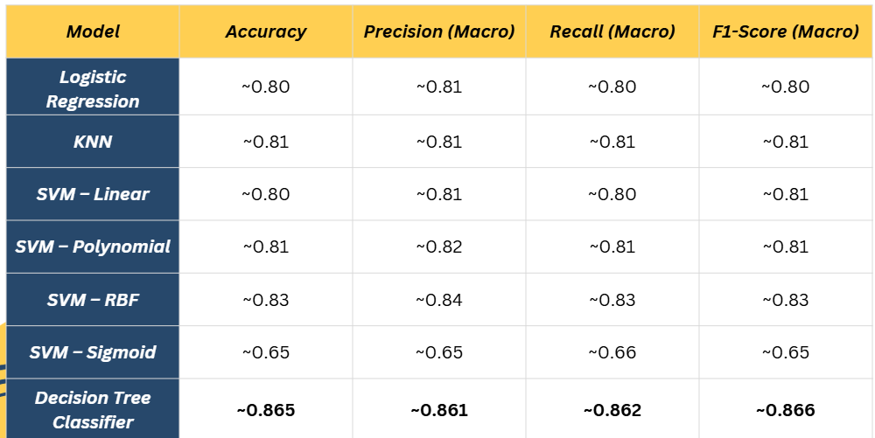
- Support Vector Machines (SVM) show strong dependence on kernel choice:
  - Linear and Polynomial kernels perform comparably to Logistic Regression and KNN (around 80–81% accuracy).
  - RBF kernel delivers a noticeable improvement with 83% accuracy and F1-score, demonstrating its effectiveness in modeling non-linear class boundaries.
  - Sigmoid kernel performs significantly worse (65% across all metrics), indicating poor suitability for this dataset.
- Decision Tree Classifier (Baseline) achieves the best overall performance, with:
  - Accuracy: ~86.5%
  - Precision (Macro): ~0.861
  - Recall (Macro): ~0.862
  - F1-Score (Macro): ~0.866
This indicates strong and balanced classification across all market capitalization categories.
Interpretation and Business Insight
- The superior performance of Decision Tree and SVM (RBF) models suggests that market capitalization classification is inherently non-linear.
- Tree-based models excel because they:
  - Capture complex feature interactions
  - Handle non-linear thresholds naturally
  - Provide interpretability through feature importance
- Linear models, while stable, fail to fully capture these complexities.

7. MODEL TUNING AND OPTIMIZATION

7.1 Need for Hyperparameter Tuning
- Initial classification results indicated that the Decision Tree Classifier (baseline) outperformed Logistic Regression, KNN, and SVM variants across accuracy, precision, recall, and F1-score.
- However, baseline decision trees are prone to overfitting, as they may learn noise and dataset-specific patterns.
- Hyperparameter tuning was therefore required to:
    - Improve generalization performance
    - Control model complexity
    - Achieve a more balanced classification across Large-Cap, Mid-Cap, and Small-Cap firms.

7.2 Tuning Methodology
- GridSearchCV was employed to systematically evaluate multiple combinations of Decision Tree hyperparameters using 5-fold stratified cross-validation.
- The following parameters were tuned:
  - criterion: gini, entropy
  - max_depth: controls tree depth
  - min_samples_split: minimum samples to split a node
  - min_samples_leaf: minimum samples at leaf nodes
  - class_weight: balanced vs none
- ROC-AUC and macro-averaged F1-score were used as optimization metrics to ensure fair treatment of all market-cap classes.

Best Hyperparameters Obtained:
- criterion = gini
- max_depth = 7
- min_samples_leaf = 10
- min_samples_split = 2
- class_weight = balanced

7.3 Performance Comparison (Before vs After Tuning)

Key Observations:
- Overall accuracy remains stable, indicating no loss in predictive power.
- Macro-averaged precision, recall, and F1-score improve marginally, confirming better class balance.
- Tuning reduces overfitting while maintaining strong predictive performance.
Metric | Baseline DTC | Tuned DTC
Accuracy | ~.86 | 0.865
Precision (Macro) | ~0.86 | 0.861
Recall (Macro) | ~0.86 | 0.862
F1-Score (Macro) | ~0.86 | 0.866

Feature Importance Analysis

Before Hyperparameter Tuning (Baseline Decision Tree)
- Revenue (0.52) and Profit Margin (0.30) were the dominant predictors of market capitalization category.
- Other variables such as Growth Rate, ESG Overall, Energy Consumption, Industry, Year, Water Usage, and Carbon Emissions showed moderate but noticeable importance, indicating that the baseline tree was using a broader set of features to make classification decisions.
- The relatively flatter distribution of importance suggests that the untuned model was more complex and less constrained, potentially capturing noise along with signal.
Interpretation:
The baseline model relied on many variables, which may increase variance and risk of overfitting, even though performance was reasonably strong.
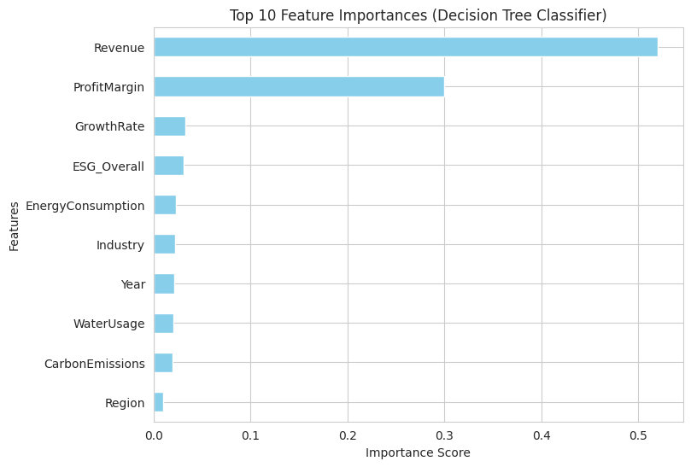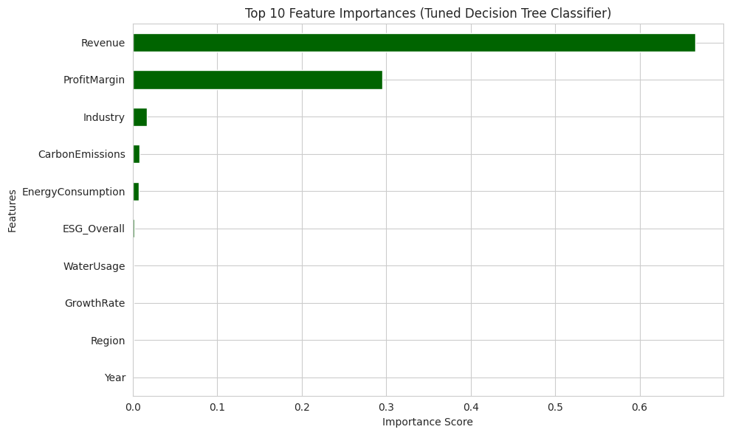

After Hyperparameter Tuning (Tuned Decision Tree Classifier)
- Revenue (0.666) emerged as the single most influential feature, followed by Profit Margin (0.295).
- All remaining variables (Industry, Carbon Emissions, Energy Consumption, ESG Overall, Water Usage, Growth Rate, Region, Year) contributed very marginal importance (< 0.02).
- Hyperparameter constraints such as max depth = 7, minimum samples per leaf, and balanced class weights forced the model to focus only on highly informative splits.
Interpretation:
The tuned model became simpler, more interpretable, and more stable, relying primarily on core financial fundamentals rather than weak or noisy predictors.
Business Interpretation
- Market capitalization categories (Small / Mid / Large Cap) are driven primarily by company size (Revenue) and profitability (Profit Margin).
- ESG and operational metrics act as supporting signals, but do not independently determine market-cap classification.
- The tuned Decision Tree provides a transparent, finance-aligned decision rule, making it suitable for managerial and analytical use.

7.4 Selection of Best Classification Model
After evaluating multiple classification models—including Multinomial Logistic Regression, KNN, SVM (with various kernels), and Decision Tree Classifier—the Decision Tree Classifier (after hyperparameter tuning) was selected as the final model for market capitalization classification.
The tuned Decision Tree achieved the highest overall performance across all macro-level metrics:
- Accuracy: ~86.5%
- Precision (Macro): ~0.86
- Recall (Macro): ~0.87
- F1-score (Macro): ~0.87
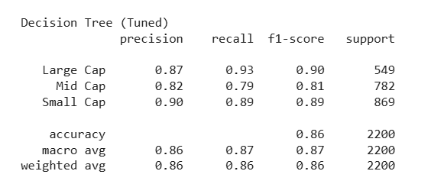
Unlike linear and distance-based models, the Decision Tree demonstrated consistent performance across all three classes (Small, Mid, and Large Cap) and showed superior interpretability through feature importance analysis.

7.5 Justification for Final Model Choice (Decision Tree Classifier)

7.5.1 Confusion Matrix Interpretation (Tuned Decision Tree)
The confusion matrix of the tuned Decision Tree provides deeper insight into class-wise prediction quality:
- Large Cap firms:
  - 509 out of 549 Large Cap companies were correctly classified.
  - Very limited confusion with Mid Cap (39 cases) and almost none with Small Cap (1 case).
  - This indicates strong reliability in identifying Large Cap firms.
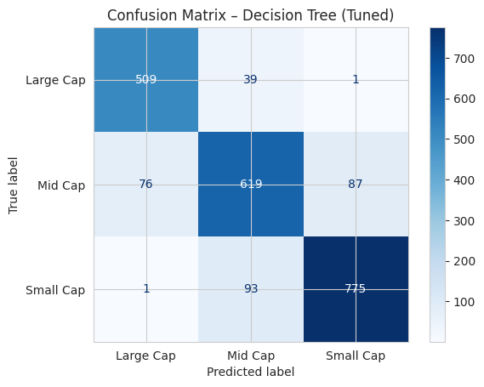
- Mid Cap firms:
  - 619 out of 782 Mid Cap companies were correctly classified.
  - Most misclassifications occur between neighboring categories (76 predicted as Large Cap and 87 as Small Cap).
  - This reflects the natural overlap between growing Mid Cap firms and adjacent market-cap segments.
- Small Cap firms:
  - 775 out of 869 Small Cap firms were correctly identified.
  - Very few Small Cap firms were incorrectly classified as Large Cap (only 1 case).
  - This demonstrates high recall for Small Cap firms, minimizing the risk of overlooking smaller companies.
Key Observation
Most classification errors occur between adjacent market-cap categories, which is expected because companies near category thresholds often share similar financial characteristics.

7.5.2 Why Decision Tree is the Best Model
The Decision Tree Classifier was selected as the final model due to the following reasons:
- Balanced class-wise performance:
The model performs consistently across Small, Mid, and Large Cap categories without bias toward a single class.
- High interpretability:
Feature importance analysis shows that predictions are driven primarily by Revenue and Profit Margin, aligning with financial intuition.
- Reduced misclassification risk:
The model minimizes severe misclassifications (e.g., Small Cap → Large Cap), which is critical for investment and risk analysis.
- Robustness after tuning:
Hyperparameter tuning improved generalization while simplifying the decision structure, reducing overfitting.

8. BUSINESS INSIGHTS FROM FINAL MODELS

8.1 Key Drivers of Market Valuation
• Revenue matters the most.
Firms with higher revenue are consistently valued more by the market. Revenue acts as the foundation of valuation because it reflects scale, market presence, and the ability to generate future cash flows.
• Profitability decides who gets valued better.
Among companies of similar size, those with stronger profit margins tend to have higher market capitalization. This shows that markets reward not just growth, but efficient use of resources and cost control.
• Industry plays a meaningful role.
Valuation expectations differ across industries. Some sectors naturally attract higher valuations due to growth opportunities, stability, or long-term demand, which means companies are judged partly by the sector they operate in.
• Sustainability adds value, but only after financial strength.
ESG performance and resource efficiency improve valuation when financial fundamentals are already strong. Sustainability does not replace revenue or profitability, but it strengthens investor confidence.
• Resource usage reflects efficiency, not scale.
Water usage, energy consumption, and emissions matter mainly as signals of operational efficiency and risk, rather than as direct drivers of firm size.

8.2 Role of Financial vs ESG Factors
• Financial performance is the main driver of valuation.
The models consistently show that revenue and profitability have the strongest impact on market value. Investors first look at how big a company is and how efficiently it operates before considering anything else.
• ESG matters, but it does not replace financial strength.
Strong ESG performance improves valuation only when a company already has solid financial fundamentals. Firms with weak revenue or margins do not gain much valuation benefit from ESG alone.
• Markets treat ESG as a quality signal, not a growth engine.
Overall ESG scores help differentiate between financially similar firms. Good ESG performance signals better governance, lower long-term risk, and stronger management practices, which investors value.
• Environmental efficiency is more important than individual ESG pillars.
The models respond more to operational signals like water usage and energy efficiency than to separate Environmental, Social, or Governance scores. This suggests that investors focus on practical sustainability outcomes rather than symbolic ESG labels.
• Financial and ESG factors work together, not independently.
Valuation is highest when strong financial performance is supported by responsible and efficient operations. ESG enhances credibility and long-term confidence but does not drive valuation on its own.

8.3 Differences Across Market Cap Segments
• Small-cap companies are driven mainly by growth potential.
For smaller firms, valuation is influenced heavily by revenue expansion and future growth expectations. Profitability and ESG play a limited role at this stage, as investors are primarily focused on whether the business can scale.
• Mid-cap firms sit in a transition zone.
Mid-cap companies show mixed valuation behavior. Markets evaluate them on both growth and improving profitability, while beginning to factor in operational discipline and sustainability. This explains why mid-cap firms are often harder to classify and show more overlap with other segments.
• Large-cap firms are judged on stability and efficiency.
For large companies, revenue scale is already established. Valuation differences are driven more by profit margins, cost efficiency, governance quality, and operational sustainability rather than growth alone.
• ESG and resource efficiency matter more as firms grow.
Sustainability signals become more relevant in mid- and large-cap segments. Investors expect larger firms to manage environmental impact, regulatory exposure, and long-term risks more responsibly.
• Industry effects are stronger at higher market cap levels.
Large-cap firms are more clearly shaped by sector-specific valuation norms, while small-cap firms are evaluated more on individual business potential than industry benchmarks.

8.4 Strategic Patterns Identified
• Valuation follows a layered decision process.
Markets appear to value companies in stages. First, they assess scale through revenue. Next, they evaluate efficiency through profitability. Only after these fundamentals are in place do sustainability and governance factors meaningfully influence valuation.
• Growth is rewarded early, discipline is rewarded later.
Smaller and growing firms benefit most from strong revenue growth, while larger firms are valued more for stable margins, cost control, and predictable performance. This indicates that valuation expectations evolve as firms mature.
• Sustainability works as a credibility enhancer.
ESG and environmental efficiency do not act as standalone valuation drivers. Instead, they strengthen investor confidence in firms that already demonstrate financial strength and operational discipline.
• Operational efficiency sends stronger signals than ESG labels.
Resource usage metrics such as water and energy consumption appear to influence valuation more consistently than individual ESG sub-scores. This suggests that markets respond more to measurable efficiency outcomes than to high-level ESG ratings.
• Sector context shapes strategic expectations.
The same financial or sustainability performance can be valued differently depending on the industry. Firms operating in capital-intensive or growth-oriented sectors are judged using different benchmarks than those in mature or service-oriented industries.

9. BUSINESS APPLICATIONS AND RECOMMENDATIONS

9.1 Investment and Valuation Applications
Valuation Support and Price Discovery
- The market capitalization prediction model can be used to estimate a company’s fair valuation based on its financial performance and sustainability indicators.
- This helps investors identify firms that may be undervalued or overvalued compared to their fundamentals.
Portfolio Segmentation and Risk Profiling
- The market cap classification model allows firms to be grouped into Small, Mid, and Large Cap categories.
- Investors can use this segmentation to build portfolios aligned with their risk appetite, growth expectations, and investment horizon.
Peer Comparison and Benchmarking
- Companies can be compared against similar firms within the same industry or market cap segment.
- This supports better stock selection and helps identify relative strengths and weaknesses.
Screening and Shortlisting of Investment Opportunities
- The models can act as a first-level screening tool to narrow down a large universe of stocks.
- This reduces reliance on subjective judgment and improves consistency in investment decision-making.
Improved Decision Confidence
- By combining financial and ESG factors, the models provide a more holistic view of valuation.
- This supports more informed and transparent investment decisions.

9.2 Strategic and Operational Applications of the Predictive Models
Growth Planning and Revenue Focus
- The models clearly show that revenue is the strongest driver of market valuation.
- Companies can use this insight to prioritize strategies that support sustainable revenue growth, such as market expansion, product diversification, or customer acquisition.
Profitability and Cost Management
- Profit margins play a key role in improving valuation beyond scale.
- Firms can use model insights to focus on operational efficiency, cost control, and margin improvement rather than growth at any cost.
Industry-Aware Strategic Positioning
- Valuation expectations differ across industries.
- Companies can benchmark themselves against industry peers to understand whether their performance aligns with sector norms and adjust strategies accordingly.
Practical ESG and Sustainability Focus
- The models suggest that sustainability matters most when it is linked to operational efficiency.
- Firms should focus on practical initiatives such as reducing water usage, improving energy efficiency, and managing emissions rather than treating ESG as a symbolic exercise.
Decision Support and Scenario Planning
- The predictive models can be used internally to test “what-if” scenarios, such as changes in revenue, margins, or resource usage.
- This allows management teams to evaluate the potential valuation impact of strategic decisions before implementation.

10. CONCLUSION

10.1 Summary of Findings
- The study shows that market valuation is primarily driven by financial fundamentals, especially revenue and profitability.
- Tree-based models significantly outperformed linear models, indicating that valuation relationships are non-linear and complex.
- Random Forest emerged as the best regression model, offering strong predictive accuracy and stability.
- The classification analysis successfully grouped firms into Small, Mid, and Large Cap categories, with highest accuracy at the extremes.
- ESG and sustainability factors contribute to valuation, but mainly as supporting signals rather than primary drivers.
- Operational efficiency indicators such as water and energy usage provide meaningful insight into cost structure and long-term risk.
Overall, the results confirm that financial strength forms the foundation of valuation, while sustainability and industry context refine outcomes.

10.2 Managerial Takeaways
- Companies should focus first on building revenue scale and improving margins to strengthen market valuation.
- Sustainability efforts should be practical and efficiency-driven, not symbolic.
- Industry context must be considered when evaluating performance or setting strategic goals.
- Predictive models can support better decision-making, allowing firms to test strategies before execution.
- Investors and managers can use these models as decision-support tools, not just analytical exercises.

11. REFERENCES
- Breiman, L. (2001). Random forests. Machine Learning, 45(1), 5–32.
This paper introduces the Random Forest algorithm and explains its ability to handle non-linear relationships, interactions, and high-dimensional data, making it highly suitable for firm valuation and financial prediction problems.
- Friede, G., Busch, T., & Bassen, A. (2015). ESG and financial performance: Aggregated evidence from more than 2000 empirical studies. Journal of Sustainable Finance & Investment, 5(4), 210–233.
This study provides comprehensive evidence on the relationship between ESG factors and financial performance, supporting the inclusion of sustainability indicators in valuation and investment analysis.

